**PRACTICAL: 2**

**DEVELOPING APPLICATION FOR WINDOWS AZURE**

**Steps:**

1. To develop an application for Windows Azure on Visual Studio install the “Microsoft Azure SDK for .NET (VS 2010) – 2.8.2.1”



Accept the license and Click on Next.

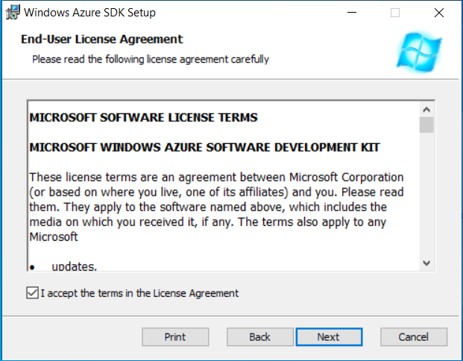

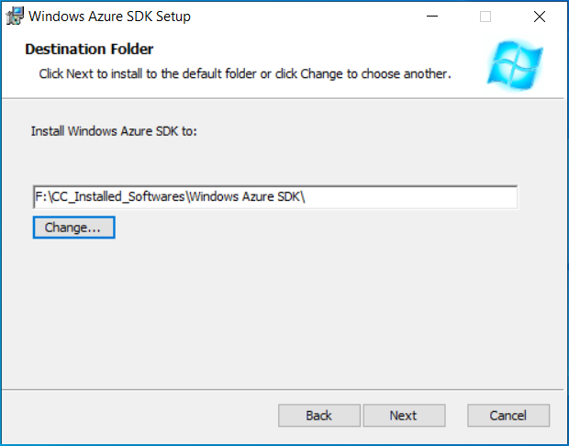

Click on Install.



Click on Finish



2. Turn windows Features ON or OFF: Go to Control panel and click on programs => programs and features.

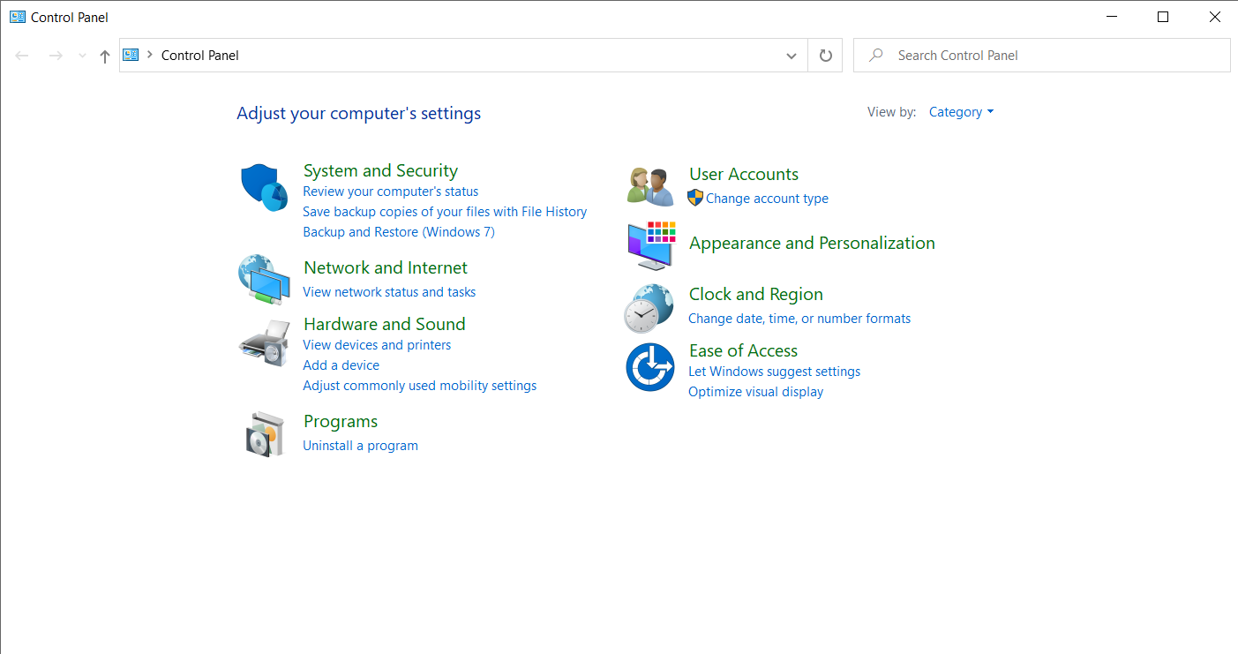

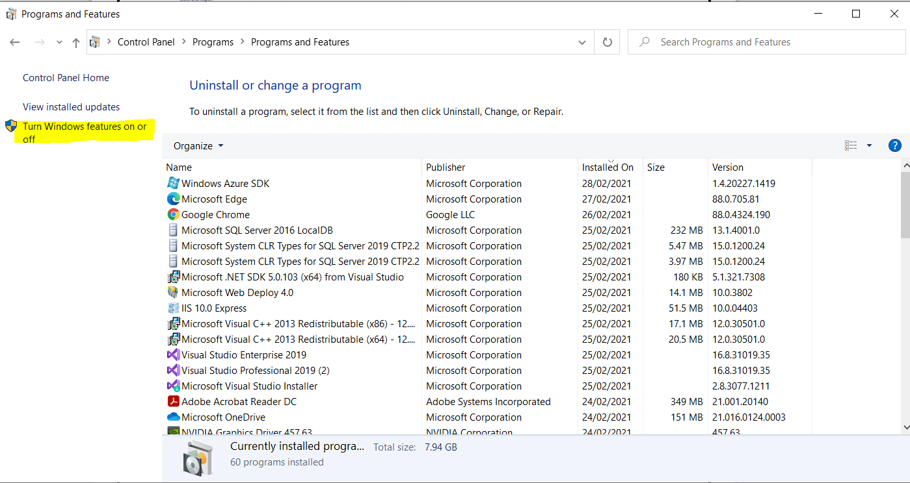

3. Expand the internet information services and select the following checkbox.

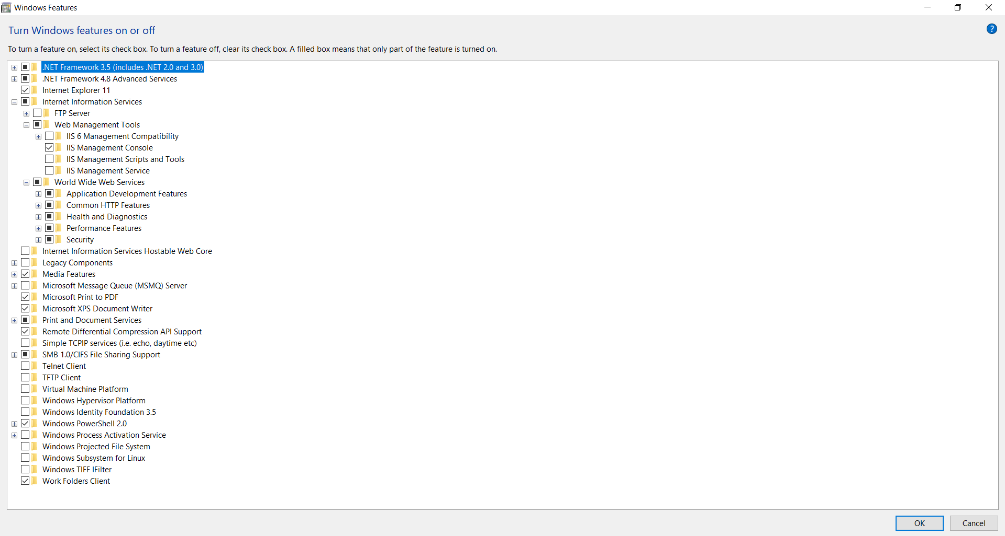

4. Now, Start the visual studio 2010 and Go to File->New->Project

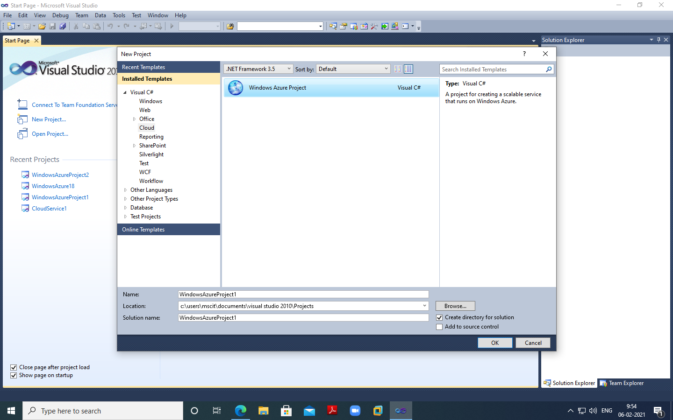

Add asp.net roles

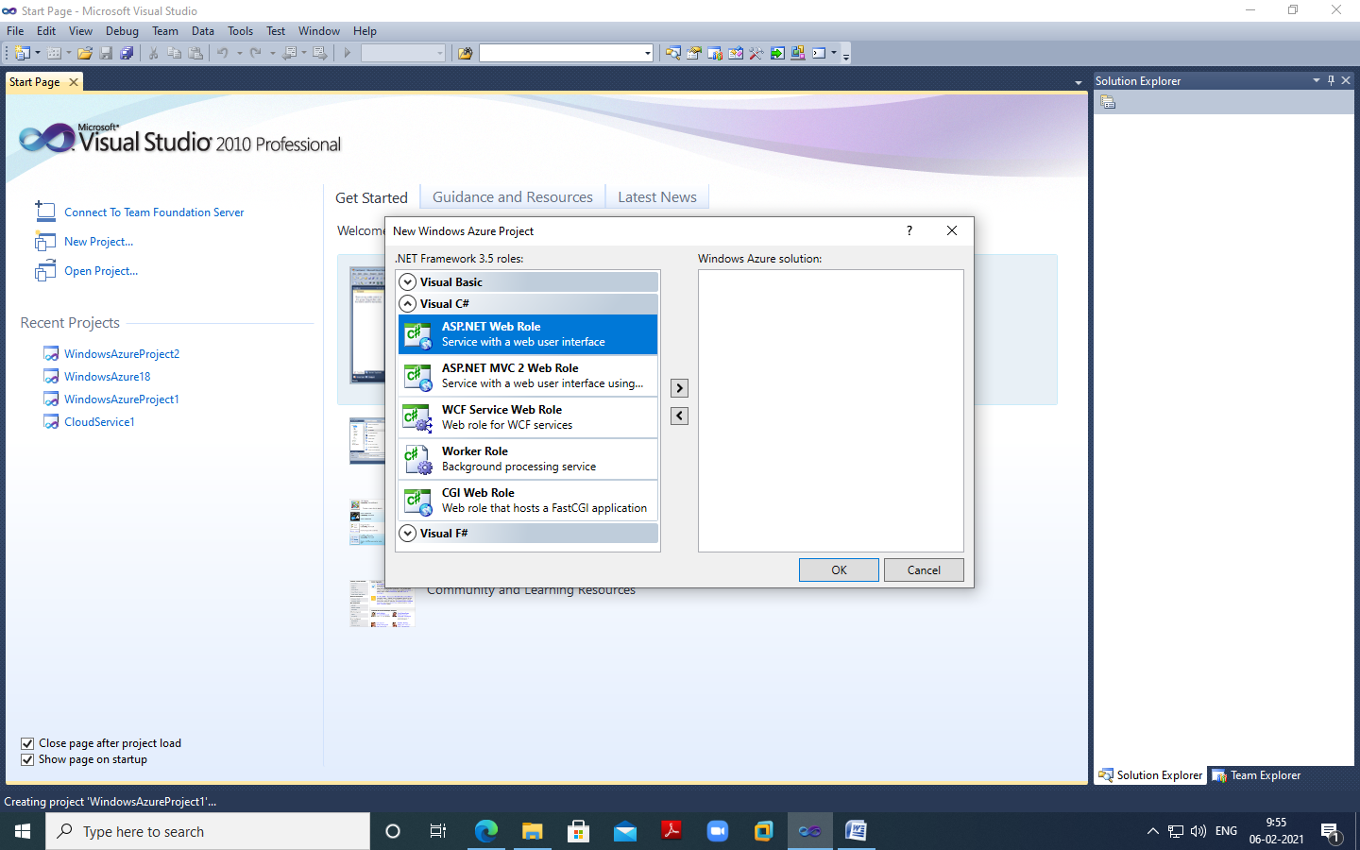

Create a web form

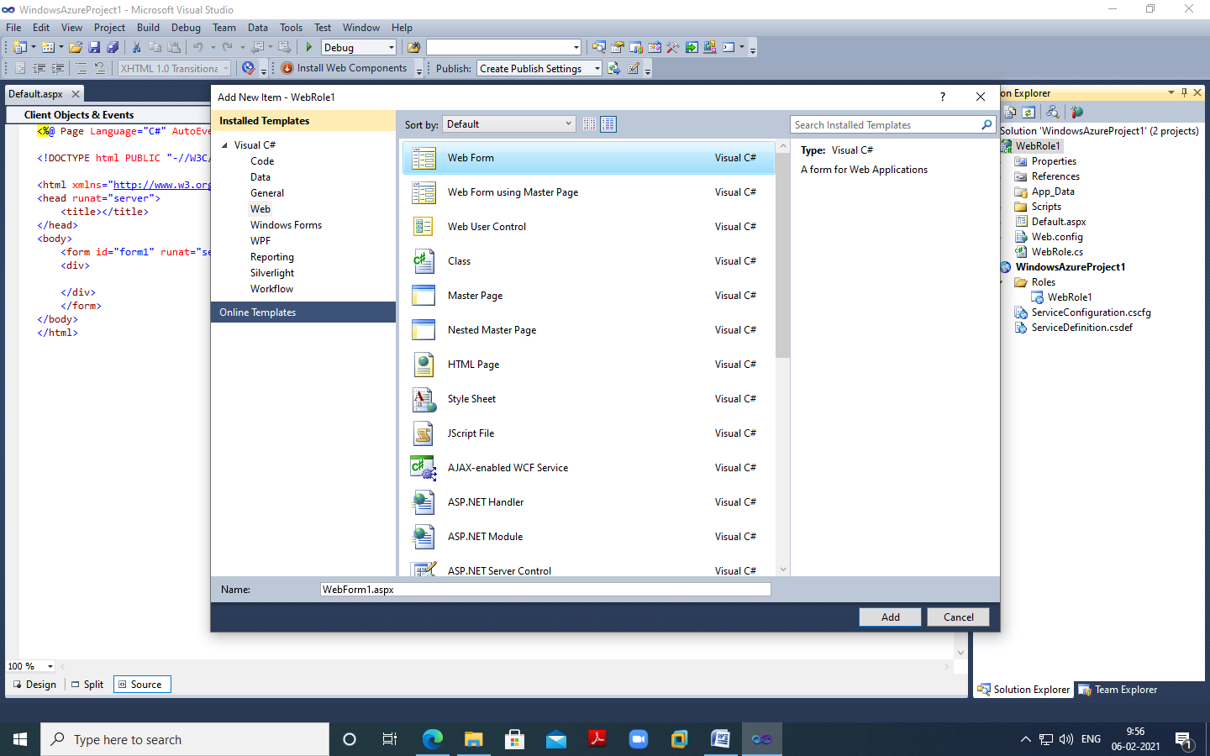

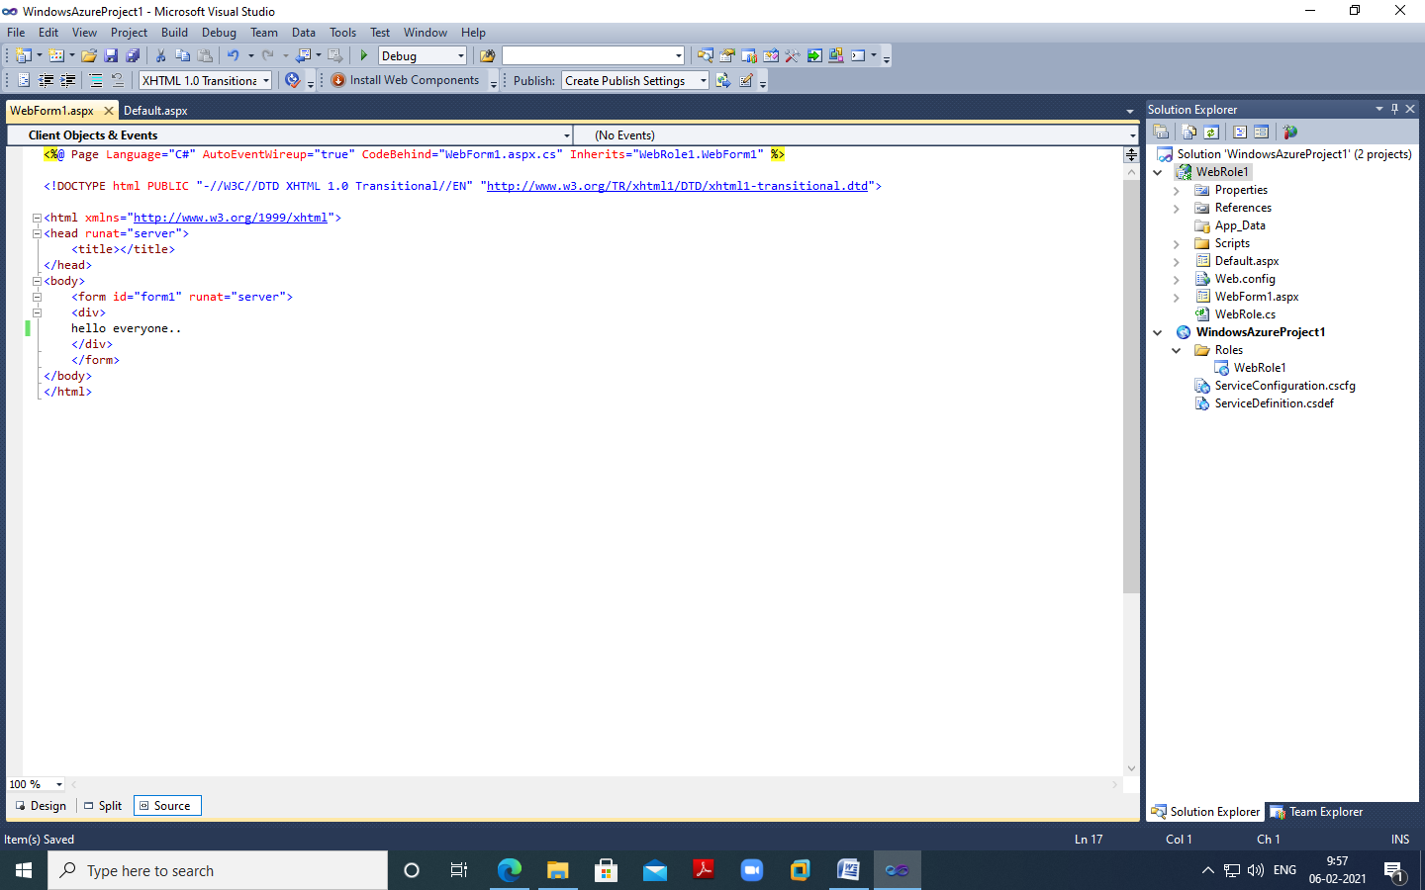

Run the website

